Install GIT & make sure it is added into PATH.

Section 0 -Use GIT as local VCS. Steps to follow:

1. Create a directory ‘project_dir’ & cd to ‘project_dir’.

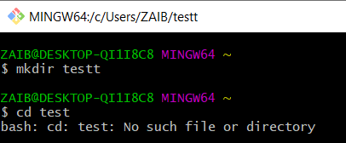

1. Initialize git version database. (git init)

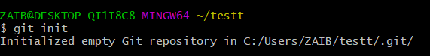

1. Create a new file index.html.

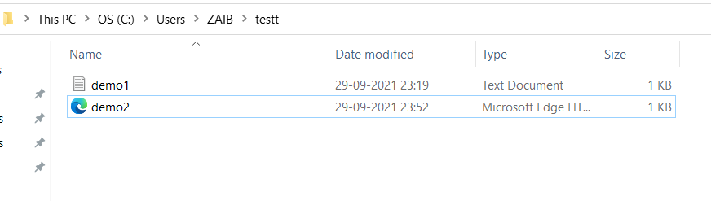

1. Check the git status. You should find index.html as untracked file.

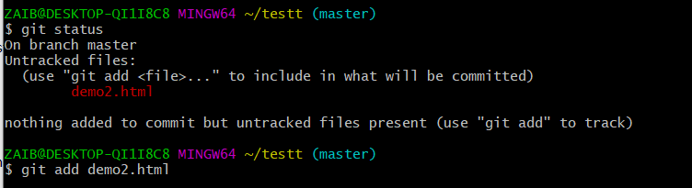

1. Stage the index.html file.

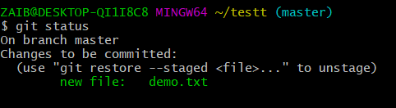

1. Commit index.html

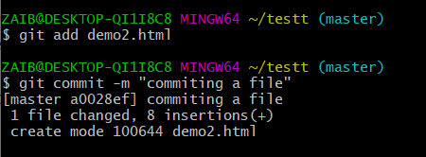

1. Make few changes in index.html & create a new file info.txt file.

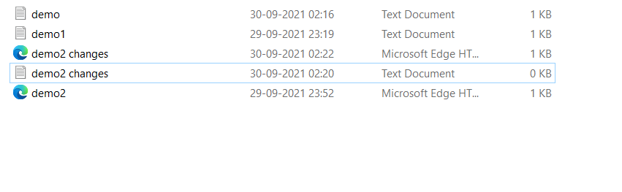

1. Check git status. You should find index.html & info.txt as untracked files.

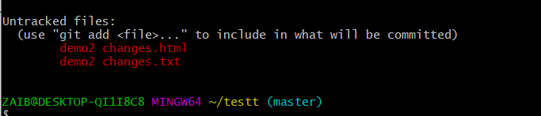

1. Configure GIT to ignore all txt files.

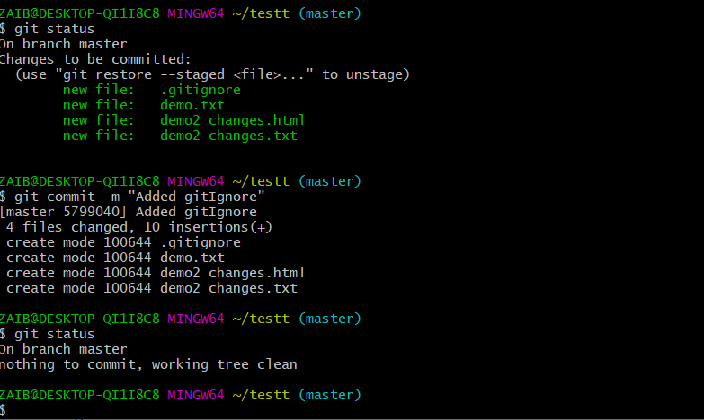

1. Again check the git status. You should find only index.html as untracked file.

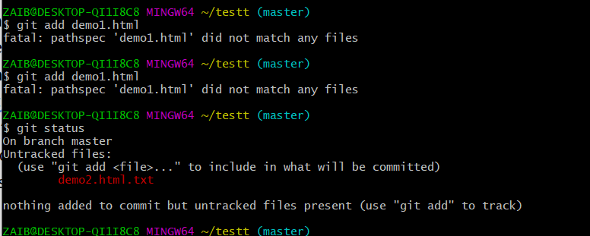

1. State & commit index.html

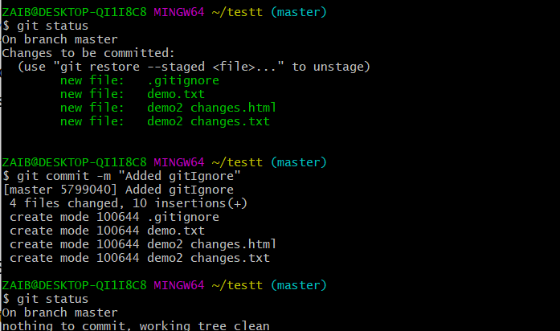

1. Log all your comments so far.

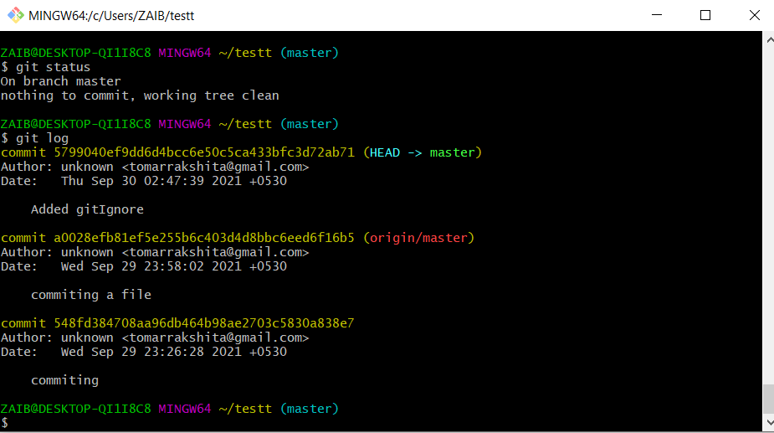

1. Make some changes in index.html.

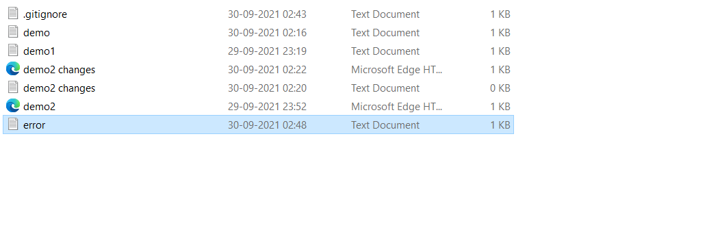

1. Revert the change made in the previous step using git command.

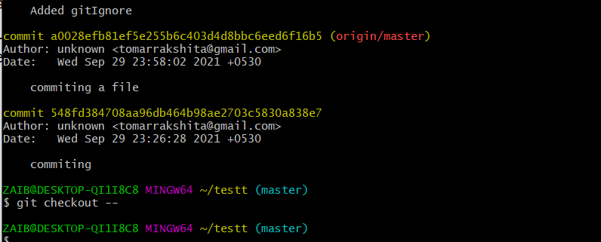

1. Again change index.html.

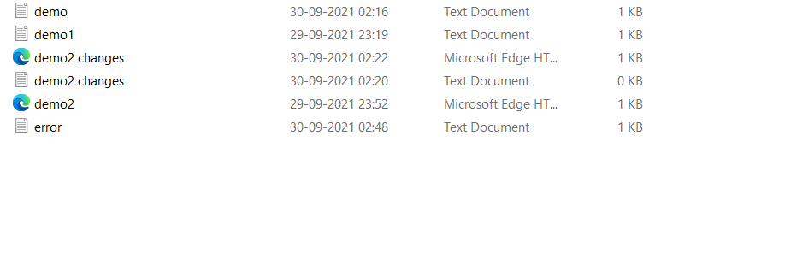

1. Stage index.html

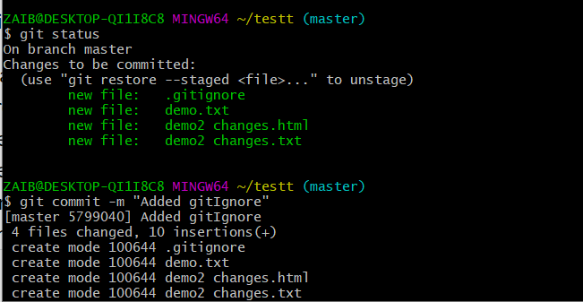

1. Revert back the last stage.

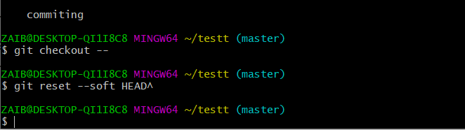

1. Rename ‘add’ command to ‘my-add’.

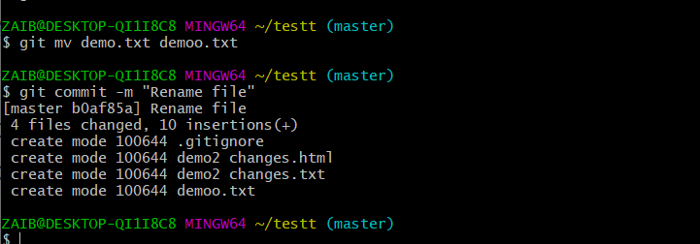

1. Using my_add command Stage index.html again & commit the changes.

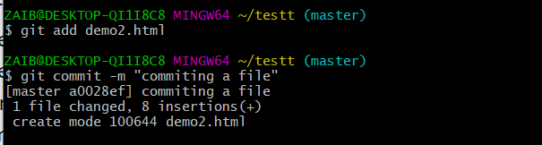

1. Revert the last commit.

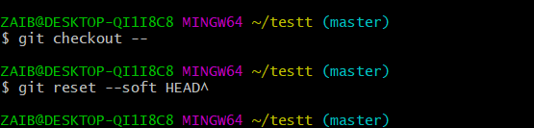

*GIT Branching*

Objective: Commit HTML, CSS & JavaScript assignments into GIT.

SECTION-1 (HTML assignments) - Steps to follow:

1. First take a backup of your assignments & projects. This is required because due to incorrect GIT operation you may lose your files.

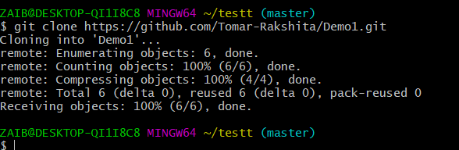

1. Create an empty directory ‘Assignments’ & cd to ‘Assignments’.

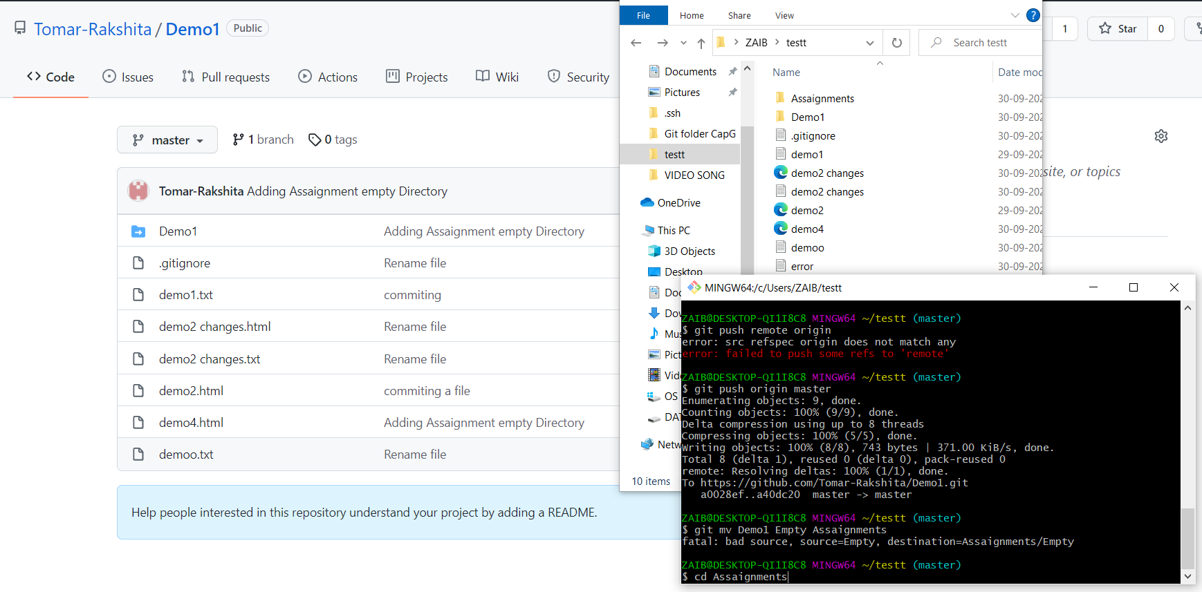

1. Create a file README.txt inside ‘Assignments’ & write few lines about the contents of ‘Assignments’ folder.

Ans : touch README.txt

1. Commit README.txt file.

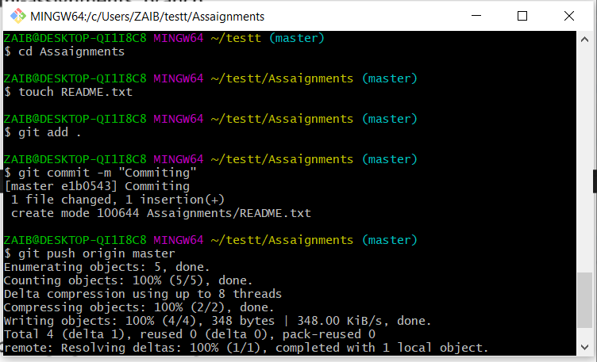

1. Now create a new branch ‘html-assignments’.

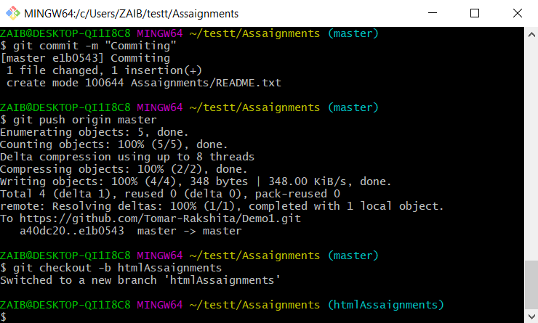

1. Switch to ‘html-assignments’ branch.

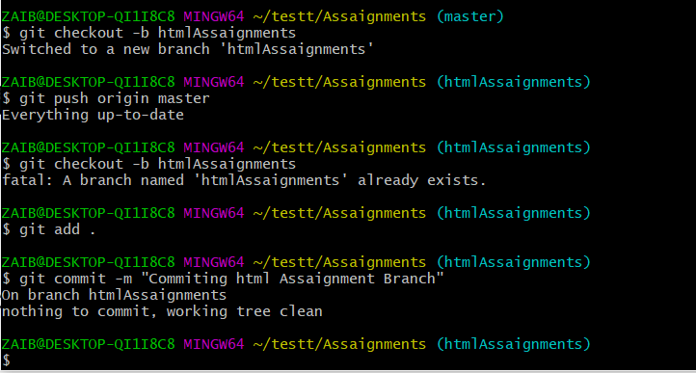

1. Copy all HTML assignments inside ‘Assignments’ folder.

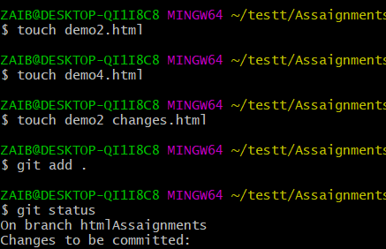

1. Commit HTML assignments into ‘html-assignments’ branch.

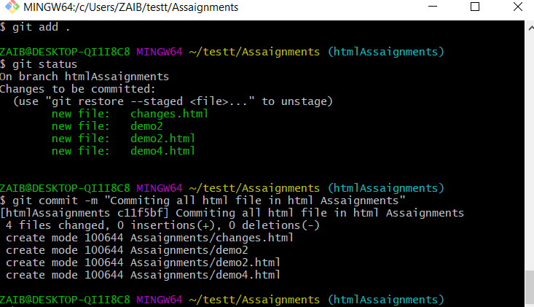

1. Make minor changes into few files belonging to ‘html-assignments’ branch.

Ans : Done new code.

1. Commit those changed files.

Ans : git Commit -m “Commiting”

1. Switch to master branch.

Ans : git checkout master

1. Make minor changes into README.txt file & commit those changes into master.

Ans :

Edit previous code.

git add .

git commit -m “Commiting”

1. Again switch to ‘html-assignments’ branch.

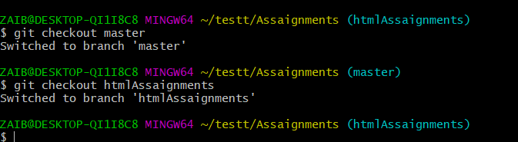

1. Make minor changes into few files belonging to ‘html-assignments’ branch.

Ans : Done some Changes.

1. Commit those changes.

Ans : git commit -m “Commiting new changes”

1. Switch to master.

Ans : git checkout master.

1. Merge ‘html-assignments’ branch into master. Confirm all html assignments are shown in master.

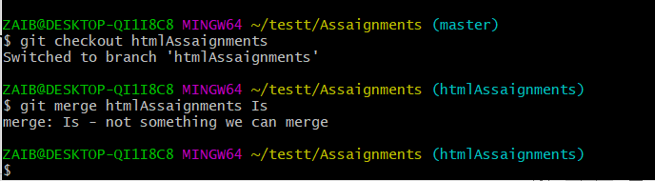

1. Finally delete the ‘html-assignments’ branch.

Ans : git branch -d htmlAssaignments

SECTION-2 - (CSS assignments) Steps to follow:

1. Create a new branch ‘css-assignments’.

Ans : git branch CssAssaignments.

1. Switch to ‘css-assignments’ branch.

Ans : git checkout CssAssaignments

1. Copy all CSS assignments inside ‘Assignments’ folder.

Ans : touch demo.css

touch demo1.css

1. Commit CSS assignments into ‘css-assignments’ branch.

Ans : git add -f demo.css demo1.css

git commit “Committing”

1. Make minor changes into README.txt file on line 1 belonging to ‘css-assignments’ branch.

Ans : Done some changes.

git init

git add README.txt

git commit -m"readme"

1. Commit those changed files.

Ans : git commit -m “Committing”

1. Switch to master branch.

Ans : git checkout master

1. Make minor changes into README.txt file on line 3 & commit those changes into master.

Ans : Done some changes.

1. Again switch to ‘css-assignments’ branch.

Ans : git checkout CssAssaignments

1. Make minor changes into few files belonging to ‘css-assignments’ branch.

Ans : Done changes in file.

1. Commit those changes.

Ans : git add .

git commit -m “committing”

1. Switch to master.

Ans : git checkout master

1. Merge ‘css-assignments’ branch into master. Confirm all css assignments are shown in master.

Ans : git merge CssAssaignments Is

1. Finally delete the ‘css-assignments’ branch.

Ans : git branch -d CssAssaignments

SECTION-3 - (JavaScript assignments) Steps to follow:

1. Create a new branch ‘js-assignments’.

Ans : git branch JssAssaignment

1. Switch to ‘js-assignments’ branch.

Ans : git checkout JssAssaignment

1. Copy all JavaScript assignments inside ‘Assignments’ folder.

Ans : touch demo1.css

touch demo2.css

1. Commit JavaScript assignments into ‘js-assignments’ branch.

Ans : git add .

git commit -m “Committing”

1. Make minor changes into README.txt file on line 1 belonging to ‘js-assignments’ branch.

Ans : Done some changes.

1. Commit those changed files.

Ans : git add .

git commit -m “Committing”

1. Switch to master branch.

Ans : git checkout master

1. Make minor changes into README.txt file on line 1 & commit those changes into master.

Ans : Done some changes.

1. Again switch to ‘js-assignments’ branch.

Ans : git checkout JssAssaignment

1. Make minor changes into few files belonging to ‘js-assignments’ branch.

Ans : Done some changes and commit it.

1. Commit those changes.

Ans : git dd .

git commit -m “Committing”

1. Switch to master.

Ans : Git checkout master

1. Merge ‘js-assignments’ branch into master. Confirm all JavaScript assignments are shown in master.

Ans : git merge JssAssaignment Is

1. Finally delete the ‘js-assignments’ branch.

Ans : git branch -d JssAssaignment

*GIT Remoting*

Objective: Pushing source code into GITHUB & collaborate team members.

SECTION-3 (Pushing assignments to remote repository) - Steps to follow:

1. Create a github account if you do not have already.

Ans : Done

1. Login on into github account.

Ans : Done

1. Create new public repository ‘freshersbatch-oct16’.
2. Commit & push any sample file to this repository under ‘Assignments’ directory.

SECTION-4 (Pushing source code to remote repository using Eclipse GIT plugin) - Steps to follow:

1. One developer from project team will create eclipse projects ‘SampleProj’ & add sample source code files. Then commit all files through eclipse GIT plugin.
2. Collaborate other team members with your github account so that they can also modify the committed files.
3. Other developers from same team will checkout all files from remote repository. This might get conflicts since certain files fail to merge. In such case, merge it manually.
4. Commit & push the ‘SampleProj’ project.